Storage Refrigerators/Freezers

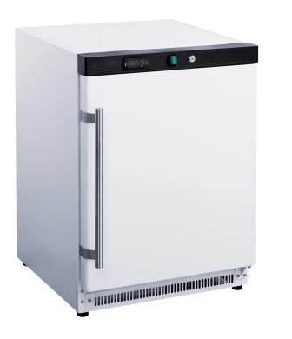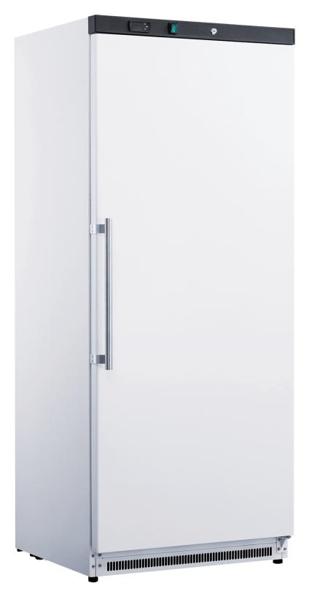
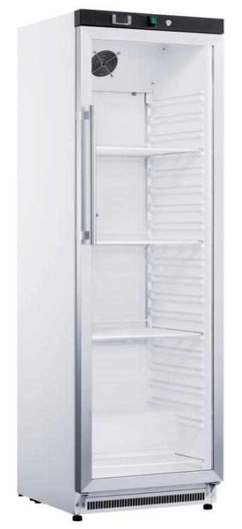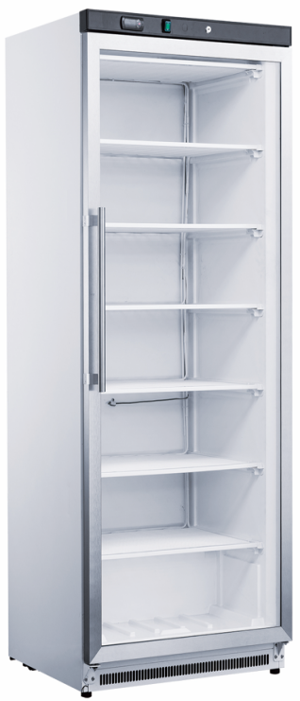

Installation, Operation & Maintenance Manual
(For refrigerant R600a /R290 only)
Safety Tips
- Position on a flat, stable surface.
- A service agent/qualified technician should carry out installation and any repairs if required. Do not remove any components or service panels on this product.
- Consult Local and National Standards to comply with
The following:
·Health and Safety at Work Legislation
·BS EN Codes of Practice
·Fire Precautions
·IEE Wiring Regulations
·Building Regulations
- WARNING: Repairs should be performed by qualified service personnel only.
- WARNING: Keep ventilation opening, in the appliance enclosure or in the built-in structure, clear of obstruction.
- WARNING: Do not use mechanical devices or other means to accelerate the defrosting process, other than those recommended by the manufacturer.
- WARNING: Do not damage the refrigerant circuit.
- WARNING: Do not use electrical appliance inside the food storage compartments of the appliance, unless they are of the type recommended by the manufacturer
- WARNING: When positioning the appliance, ensure the supply cord is not trapped or damaged.
- WARNING: Do not locate multiple portable socket-outlets or portable power supplies at the rear of the appliance
- WARNING: Cleaning and user maintenance shall not be made by children without supervision.
- WARNING: Please according to local regulations regarding disposal of the appliance for its flammable blowing gas.
- WARNING: Before you scrap the appliance, please take off the doors to prevent children trapped.
- WARNING: The appliances which have door lamps can only be replaced by the manufacturer, can NOT be replaced by the user.
- WARNING: This appliance is not intended for use by persons (including children) with reduced physical, sensory or mental capabilities, or lack of experience and knowledge, unless they have been given supervision or instruction concerning use of the appliance by a person responsible for their safety.
- WARNING: Children should be supervised to ensure that they do not play with the appliance.
- WARNING: Do not store explosive substances such as aerosol cans with a flammable propellant in this appliance.
- WARNING: If the supply cord is damaged, it must be replaced by the manufacturer, its service agent or similarly qualified persons in order to avoid a hazard.
- WARNING: DO NOT use jet/pressure washers to clean the appliance.
- WARNING: DO NOT use the appliance outside.
- WARNING: DO NOT use this appliance to store medical supplies.
- WARNING: DO NOT stand or support yourself on the base, drawers or doors.
- WARNING: DO NOT allow oil or fat to come into contact with the plastic components or door seal. Clean immediately if contact occurs.
- WARNING: Bottles that contain a high percentage of alcohol must be sealed and placed vertically in the refrigerator.
- WARNING: Always carry, store and handle the appliance in a vertical position and move by holding the base of the appliance.
- WARNING: Always switch off and disconnect the power supply to the unit before cleaning.
- WARNING: The maximum loading weight for each layer of shelf should be no more than 30kgs.

Introduction
Please take a few moments to carefully read through this manual. Correct maintenance and operation of this machine will provide the best possible performance from your product.

Pack Contents
·Refrigerator or Freezer
·Shelves (as per standard or agreed)
·Keys x 2
·Door handle and fixing screws (or as per request)
·Instruction manual
We pride ourselves on quality and service, ensuring that at the time of packing the contents are supplied fully functional and free of damage. Should you find any damage as a result of transit, please contact your dealer immediately.

Installation
Note: If the appliance has not been stored or moved in an upright position, let it stand upright for approximately 12 hours before operation. If in doubt allow the appliance to stand.
- Remove the appliance from the packaging. Make sure that all protective plastic film and coatings are thoroughly removed from all surfaces.
2. Maintain a distance of 20cm (7 inches) between the unit and walls or other objects for ventilation. Increase this distance if the obstacle is a heat source.
Note: Before using the appliance for the first time, clean the shelves and interior with soapy water.
3. Set the brakes on the castors to keep the appliance in position OR level the appliance by adjusting the screw feet.
Note: This equipment shall only be used under Climate class 4, with ambient temperature no higher than 32°C.

Lock/Unlock the Doors
A lock is fitted to the doors to ensure foodstuffs are kept
secure within your appliance.
Use the keys provided to lock/unlock the door.

Fitting the Shelves
- For chillers, the shelves are adjustable by putting it into different plastic layers.
- For freezers, the evaporator itself is used as shelves. The quantities vary by different model/capacity. Be careful not not damage the pipes by hitting the evaporator/shelves with too much strength.
- In case any damage or defects found with the shelves, please contact your dealers.
Operation
Storing Food
To get the best result from your appliance, follow these instructions:
·Only store food stuffs in the appliance when it has reached the correct operating temperature.
·Do not place uncovered hot food or liquid inside the appliance.
·Warp or cover food where possible.
·Do not obstruct the fans inside the appliance.
·Avoid opening the doors for prolonged periods of time.

Turn on the appliance
- Close the door(s) of the appliance.
- Ensure the power switch is set to [O] and turn on at the socket.
- Switch on the power [l]. The current temperature within the appliance is displayed.
Defrosting method：
1.Auto defrost (Only the refrigerator has this function)
The appliance will automatically run a defrost cycle every 8 hours.
Note: The cycle starts from the time the appliance is initially powered up.
2.To manually defrost the appliance:
- Press and hold the DEFROST button for 5 seconds.
- The defrost cycle will start immediately and the Defrost LET illuminates. The defrost will last a maximum of 20 minutes.
Note: Starting a manual defrost also resets the automatic defrost timer. The next automatic defrost will start 8
hours after the manual defrost has finished.
Cleaning, Care & Maintenance
·Switch off and disconnect from the power supply before cleaning.
·Clean the interior of the appliance as often as possible.
·Do not use abrasive cleaning agents. These can leave harmful residues.
·Do not use sharp tools cleaning the cabinets, which will break the ABS plastic liner.
·Clean the door seal with water only.
·Always wipe dry after cleaning.
·Do not allow water used in cleaning to run through the drain hole into the evaporation pan.
·Take care when cleaning the rear of the appliance. Sharp edges can cut.
·An agent or qualified technician must carry out repairs if required.

Cleaning the Condenser
Periodically (every 30 days) cleaning the condenser can extend the life of the appliance.
We recommend that our agent or qualified technician clean the condenser.
Operation Instructions
1. Temperature adjusts
Electronic Temperature Control Settings
Features
This electronic digital thermostat is a comprehensive intelligent controller.
Main functions: temperature display, temperature control, manual operation, manual defrost, light control, self-setting, parameter locking
Control panel:
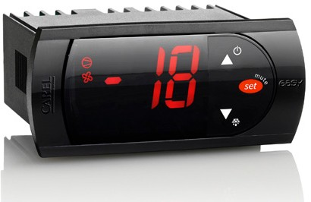
1.1 Default temperature at startup
Setting the set point (desired temperature)
• press for 1 s, the set value will start flashing after a few moments;
• increase or decrease the value using or;
• press to confirm the new value.

①Manual defrost
press down for DOWN more than 3 s (the defrost starts only the temperature conditions are
valid).

②Access and setting type F (frequent) and type C (configuration) parameters
•Press SET for 3 s (the display will show “PS”);
•To access the type F and C parameter menu, enter the password “22” using UP/DOWN;
•Press SET to confirm the password;
•Scroll inside the parameter menu using UP / DOWN. To display/set the values of the parameter displayed, press, then / and finally to
confirm the changes (returning to the parameter menu).
•To save all the new values and exit the parameter menu, press for 3 s;
•To exit the menu without saving the changed values (exit by timeout) do not press any button for at least 60 s.

1.2 Display and functions
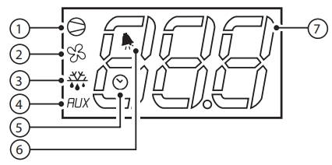
During normal operation, the controller displays the ambient temperature. In addition, the display has LEDs that indicate the activation of the control functions (see Table 1),

Index | Function | Normal operation |  |  | Start up
Index | Function | ON | OFF | blink | Start up
1 | Compressor | on | off | request | on
2 | Fan | on | off | request | on
3 | Defrost | on | off | request | on
4 | AUX | Output on | Output off | - | on
5 | RTC | RTC (usable, action tEN=1), and at least one time period has been set | RTC (unavailable or not working tEN=0) or the time period is not set |  | Turn on (if the clock card has already been configured)
6 | alarm | Alarming | No Alarm | - | on
7 | Digit | 3digit LED display with sign (-99 to 99) and decimal point
Table 1

1.3 Table of functions activated by the buttons
Button | Normal operation |  | Start up
Button | Pressing the button alone | Pressed together
 | more than 3 s: toggle ON/OFF | pressed together display defrost probe temp. | -
 | more than 3 s: start/stop defrost | pressed together display defrost probe temp. | Pressed together Start parameter reset procedure | For 1 s: display  firmware vers.  code
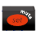 | 1 s: display/set the set point  More than 3 s: access  parameter setting menu (enter password ‘22’) | - | Pressed together Start parameter reset procedure
Table 2

1.4 Alarm and Table of alarm
When an alarm occurs, the display will alternately show the corresponding information and temperature; if the configured buzzer is enabled, the buzzer and alarm relay will also be activated. All alarms have an automatic reset (that is, the alarm will stop when the cause of the alarm no longer exists), except for manually resetting “CHt” alarms (using the UP key to turn the device on/off or by cutting off the power). Press SET to mute the buzzer, and once the cause of the alarm is resolved, the code displayed on the screen will disappear and the alarm relay will deactivate the alarm.
Alarm code | Display | LED | Description | Parameters  involved
E0 | 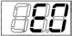 | ON | probe 1 error = control | -
E1(*) | 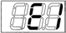 | ON | probe 2 error = defrost | [d0 = 0 / 1]
Lo | 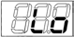 | ON | low temperature alarm | [AL] [Ad][A0]
HI | 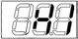 | ON | high temperature alarm | [AH] [Ad][A0]
EE | 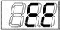 | ON | unit parameter error | -
EF | 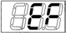 | ON | operating parameter error | -
Table 3

INSTRUCTION OF SHELF POSITION OF COOLER VERSION
As shown in the below picture, the bottom shelf should be placed at the bottom and the other shelves can be placed as per user’s requirements. The position of bottom shelf is affected the ventilation inside and also the energy consumption.
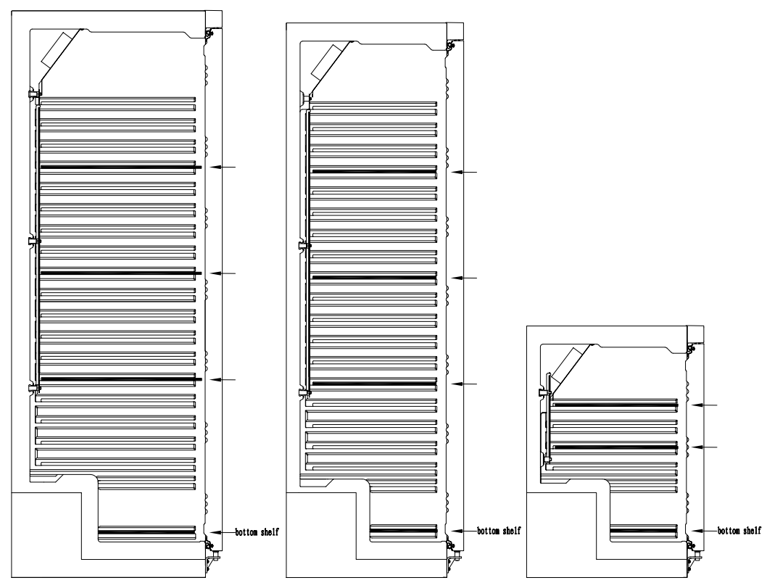

Troubleshooting
If your appliance develops a fault, please check the following table before making a call to your retailer.
Fault | Probable Cause | Action
The appliance is not working | The unit is not switched on | Check the unit is plugged in correctly and switched on
The appliance is not working | Plug and lead are damaged | Call your agent or qualified technician
The appliance is not working | Fuse in the plug has blown | Replace the fuse
The appliance is not working | Power supply | Check power supply
The appliance is not working | Internal wiring fault | Call your agent or qualified technician
The appliance turns on, but the temperature is too high/low | Too much ice on the evaporator | Defrost the appliance
The appliance turns on, but the temperature is too high/low | The fan doesn’t work | Call your agent or qualified technician
The appliance turns on, but the temperature is too high/low | Condenser blocked with dust | Call your agent or qualified technician
Fault | Probable Cause | Action
The appliance turns on, but the temperature is too high/low | Doors are not shut properly | Check doors are shut and seals are not damaged
The appliance turns on, but the temperature is too high/low | Appliance is located near a heat source or air flow to the condenser is being interrupted | Move the refrigerator to a more suitable location
The appliance turns on, but the temperature is too high/low | Ambient temperature is too high | Increase ventilation or move appliance to a cooler position
The appliance turns on, but the temperature is too high/low | Unsuitable foodstuffs are being stored in the appliance | Remove any excessive hot foodstuffs or blockages to the fan
The appliance turns on, but the temperature is too high/low | Appliance is overloaded | Reduce the amount of food stored in the appliance
The appliance is leaking water | The appliance is not properly levelled | Adjust the screw feet to level the appliance (If applicable)
The appliance is leaking water | The discharge outside is blocked | Clear the discharge outlet
The appliance is leaking water | Movement of water to the drain is obstructed | Clear the floor of the appliance (if applicable)
The appliance is leaking water | The water container is damaged | Call your agent or qualified technician
The appliance is leaking water | The drip tray is over flowing | Empty the drip tray (if applicable)
The appliance is unusually loud | Loose nut/screw | Check and tighten all nuts and screws
The appliance is unusually loud | The appliance has not been installed in a level or stable position | Check installation position and change if necessary

Electrical Wiring
Appliances are supplied with a 3 pin, moulded, BS1363 plug and lead, with a 13 amp fuse as standard.
The plug is to be connected to a suitable mains socket. Appliances are wired as follows:
Live wire (colored brown) to terminal marked L
Neutral wire (colored blue) to terminal marked N
Earth wire (colored green) to terminal marked E
All appliances must be earthed, using a dedicated earthing circuit.
If in doubt consult a qualified electrician.
Electrical isolation points must be kept clear of any obstructions. In the event of any emergency disconnection being
required they must be readily accessible.

R600a / R290 refrigerant is used for this equipment.
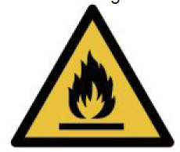
Caution!
Consult reprair manual/ower’s guide before attempting to install or service this product. All safety precautions must be followed. Dispose of properly in accordance with federal or local regulations. Risk of fire or explosion due to puncture of refrigerant tubing. Follow handling instructions carefully.
Danger!
Risk of fire or explosion. Flammable refrigerant used. To be repaired only by trained service personnel. Do not use mechanical devices to defrost refrigerator. Do not puncture refrigerant tubing.


Disposal
EU regulations require refrigeration product to be disposed of by specialist companies who remove or recycle all glasses,
metal and plastic components.
Consult your local waste collection authority regarding disposal of your appliance. Local authorities are not obliged to
dispose of commercial refrigeration equipment but may be able to offer advice on how to dispose of the equipment locally.
All packaging materials should be disposed of in an environmentally friendly way.
The cardboard may be used as scrap paper. The protective foil and the foam cushions are CFD-free.
Do not allow children to play with the packaging and destroy plastic gags safely.

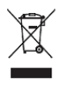
Environmental protection
Discarded electric appliances are recyclable and should not be discarded in the domestic waste! Please actively support us in conserving resources and protecting the environment by returning this appliance to the collections centers (if available).

Compliance
Parts have undergone strict product testing in order to comply with regulatory standards and specification set by
international, independent, and federal authorities.
Products have been approved to carry the following symbol:

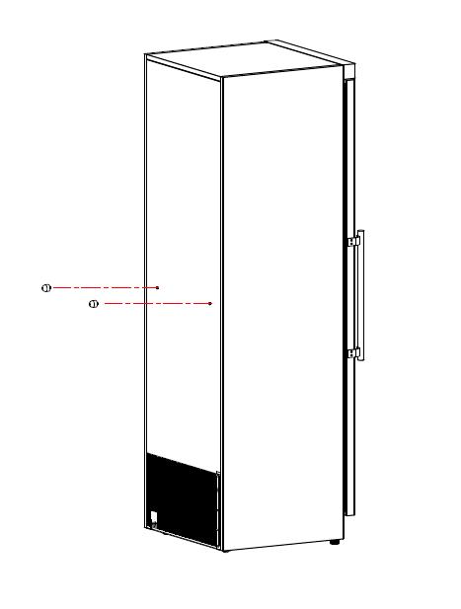
The rubber spacer must be screwed into the back side of the cabinets as showed above to ensure proper distance especially when the unit is placed against the wall. Failure to do so may void warranty and cause failures to the compressor.

